**CASE STUDY**

**UX Portfolio Case Study**

**Introduction to User Experience (UX) Course**

The User Experience (UX) course is designed to provide students with a comprehensive understanding of the principles and practices involved in creating effective and engaging user experiences. Throughout the course, students will learn about key UX methodologies such as user research, persona creation, wireframing, prototyping, usability testing, and iterative design. The course emphasizes a user-centered design approach, ensuring that all decisions are grounded in real user needs and behaviors. By the end of the course, students will be equipped with the skills to design intuitive, accessible, and user-friendly digital products, ready to make a significant impact in the field of UX design

|  |  |
| --- | --- |
| TITLE | Case Study: UX Portfolio Case Study |
| AUTHORED BY | Nguyen Chi Thao |
| DATE | 2024/08/31 |

## Portfolio Basics

What a portfolio is what it’s used for.

Portfolio is a tool to communicate and reflect your personal brand including:

* Values
* Skills and expertise
* Areas of interest and specialization
* Philosophy
* Process
* Experience and education

## Building a Starter Portfolio

## **Case Study Checklist**

1. **Articulate Portfolio Purpose**
   * Describe what a portfolio is used for.
   * Explain what a portfolio demonstrates.
2. **Create Project Case Study**
   * Balance text and visual content (30:70 to 70:30 ratio).
   * Include project name.
   * Include project duration.
   * List tools used.
   * Provide project challenge or problem statement.
   * Detail design process phases:
     + Research
     + Discovery
     + Definition
     + Prototyping
     + Concepts
     + Testing
     + Iteration
   * State project solution or outcome.
   * Use clear visuals (no blurry, pixelated, or dark photos).
   * Include prototype link or high-fidelity wireframes.
3. **Create “About Me” Page**
   * Write a short paragraph about yourself.
   * Include design philosophy or influence.
   * Describe design process or approach.
   * List relevant skills.
   * Mention professional experience (if applicable).
   * State education (if applicable).
   * Include personal and/or professional interests.
4. **Learning Reflection Write-up**
   * Reflect on project design process, decisions, and outcomes.
   * Answer the following:
     + What was your process?
     + What skills or expertise did you use?
     + What key activities happened in the project?
     + What interesting or critical insights or findings did you encounter?
     + What key tradeoffs or decisions did you make?
     + What constraints or challenges arose?
     + How did you arrive at your solution or conclusion?
     + What impact did your design have?
5. **Enhance Project Presentation**
   * Include user research, design, prototyping, and testing.
   * Capture key insights and findings.
   * Create captions for visual content.
6. **Prepare Online Portfolio**
   * Complete an online version of the case study.
   * Include the “About Me” page online.
7. **Expand Portfolio Content**
   * Include a second project case study.
8. **Final Review**
   * Ensure the portfolio tells a compelling story.
   * Highlight contributions, skills, and project impact.

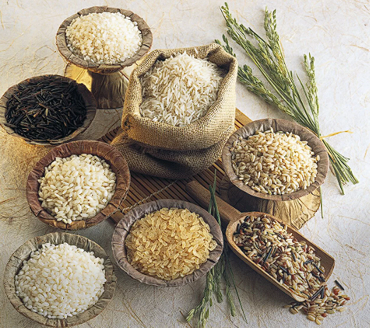**Challenge or Problem Overview**  
In the rice management industry, handling processes from harvest to distribution presents several challenges. Key issues include accurately tracking the harvest process, efficiently managing inventory, and processing orders swiftly. Particularly, managing data related to harvested quantities, inventory levels, and current orders can become complex and prone to errors without an appropriate support system.

Currently, many rice management systems rely on manual methods or non-integrated tools, leading to time inefficiencies, difficulties in tracking and reporting, and data errors. The lack of synchronization between departments and management tools results in reduced operational efficiency, affecting the ability to respond quickly to market demands and manage resources effectively.

Our "Rice Management" project aims to address these challenges by developing an integrated user interface that enables comprehensive management of processes, from harvesting and inventory tracking to order processing and sales invoicing. The goal is to create a user-friendly, efficient system that integrates essential functions to optimize management processes and support business decision-making.

### Research & Analysis

To address the challenges in rice management, a thorough research and analysis phase is crucial. Our approach involves examining existing systems, understanding user needs, and identifying gaps in current practices. The research focuses on several key areas:

1. **Current Systems and Tools**: We analyzed existing rice management systems to understand their functionalities, limitations, and user feedback. This analysis includes evaluating both manual and digital solutions, identifying common pain points, and assessing the efficiency of different tools.
2. **User Needs and Preferences**: By conducting interviews and surveys with stakeholders such as farmers, inventory managers, and sales personnel, we gathered insights into their specific needs and preferences. This helps in designing features that address real-world challenges and improve user experience.
3. **Process Mapping**: We mapped out the entire rice management workflow, including harvesting, inventory management, order processing, and sales tracking. This process mapping highlights areas where inefficiencies occur and where integration can streamline operations.
4. **Competitive Analysis**: We reviewed competitor systems to understand the features and functionalities they offer. This competitive analysis helps in identifying best practices and opportunities for differentiation in our solution.
5. **Technological Trends**: We explored current technological trends and tools that could enhance the rice management process. This includes advancements in data integration, automation, and user interface design.

Using Miro as a collaborative tool, we have visualized our findings and organized information to facilitate ideation and design. Miro has been instrumental in creating a visual representation of the research data, brainstorming solutions, and developing user flow diagrams that guide the design process.

Miro: https://miro.com/welcomeonboard/SUs1SUxyeG1KbzRWOWRoS1V1eVR6bEd6cjh1UnJMeVh3SDJuTFRiakg0bzBFQ2hRQXNHOWNZcndVeER3SU1naHwzNDU4NzY0NTk2NzEzNDQxMjY1fDI=?share_link_id=204881037330

### Design

We have developed a high-fidelity prototype of the product using figma. Please use link mentioned below to have a look at the prototype

1. Style Guide

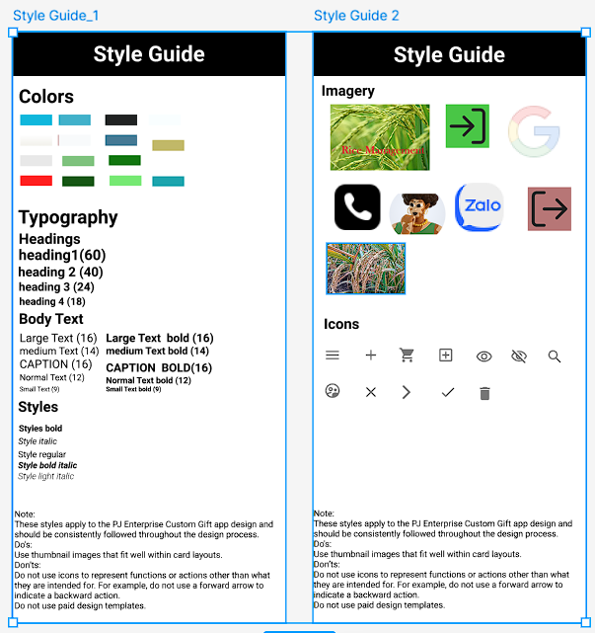

1. Partern Lib  
   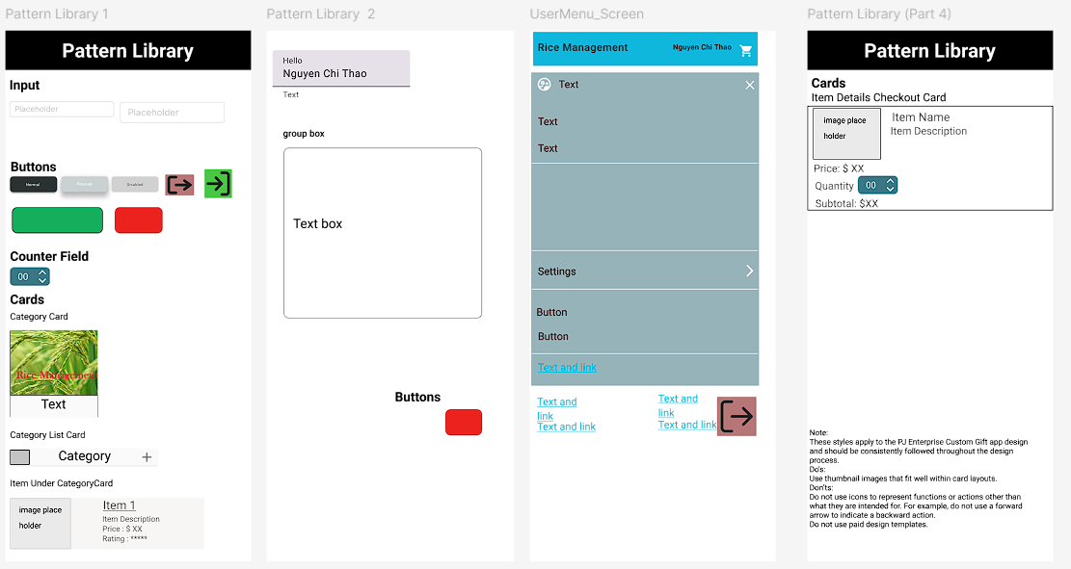
2. Login state  
   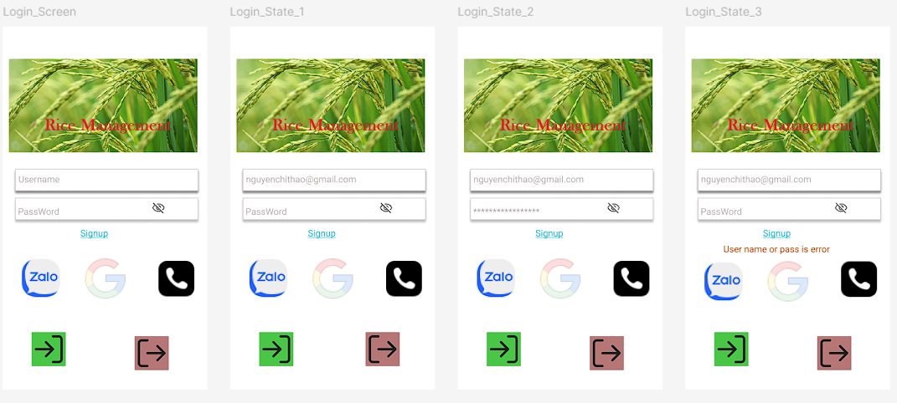
3. Sample flow : Payment Flow  
   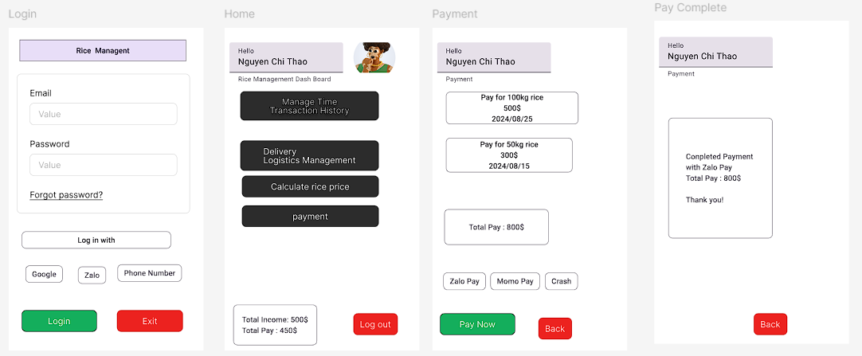
4. Fima all resource: https://www.figma.com/design/1RU0f9hi2Q38H7qssKeaa3/C3_Final_Project_Rice_managerment?node-id=2003-270&t=h7Iv5fty23LiPZN5-1
5. Figma Proto : <https://www.figma.com/proto/1RU0f9hi2Q38H7qssKeaa3/C3_Final_Project_Rice_managerment?node-id=2003-449&node-type=CANVAS&t=h7Iv5fty23LiPZN5-0&scaling=min-zoom&content-scaling=fixed&page-id=2003%3A270>
6. Payment Flow: <https://www.figma.com/proto/ZycpJVEazEtJ50ZLHN4Y0B/PaymentFlow?node-id=2003-449&node-type=CANVAS&t=EDeyChdNonwbGgyh-0&scaling=min-zoom&content-scaling=fixed&page-id=2003%3A270>

### About Me

Nguyễn Chí Thảo is a seasoned Project Manager with over 10 years of experience in the field. Fluent in both English and French, Thảo specializes in capturing and translating client requirements into actionable tasks for the team. With a strong background in project management, Thảo ensures efficient execution and delivery of projects. Thảo’s expertise in communication and client relations contributes significantly to project success.

Reflecting On Your Learning

**Learning Reflection for Rice Management Project**

As Nguyen Chi Thao, a project manager, my goal in taking the UX course was to experience firsthand the challenges my team faces in creating user-centered designs. Through this course, I aimed to better understand the UX process and gain insights into how to improve our products and workflows.

For the Rice Management project, I adopted an iterative design approach to develop a user-friendly system that addresses the needs of farmers and distributors. My process began with conducting thorough user research to identify key pain points in rice production and sales management. Using insights from this research, I developed low-fidelity prototypes and engaged with potential users to gather feedback on usability. Based on this feedback, I refined the design, enhancing features to improve user experience and functionality.

Key activities included organizing user interviews, conducting usability tests, and analyzing feedback to make informed design decisions. One of the most valuable insights from this process was discovering the importance of simplicity and clarity in the user interface, particularly for users who may not be tech-savvy. This realization guided us in simplifying the design while maintaining essential functionality.

A significant challenge I encountered was balancing the need for a comprehensive solution with the constraints of development resources and time. I had to make trade-offs, such as limiting certain advanced features to focus on core functionalities that deliver immediate value to users. This decision proved effective, as it allowed us to deliver a polished product that met user needs and enhanced productivity.

By the end of the project, I gained a deeper appreciation for the UX process and its impact on creating meaningful, user-centric solutions. I am confident that the skills and knowledge acquired through this experience will help me lead my team more effectively in future projects, ensuring our designs are both innovative and user-friendly.

I had to explore the lessons on my own and submitted my project multiple times. I am very fortunate to have reviewers who were always supportive and helpful. They guided me to recognize my own shortcomings and provided constructive feedback that was crucial in refining my work. This iterative process of submitting and receiving feedback was invaluable in helping me understand the finer details of UX design and the importance of attention to detail. It also highlighted the areas where I needed to improve, enabling me to enhance my skills further.

Through this experience, I learned the value of perseverance and the importance of continuous learning in the field of UX. The guidance from reviewers helped me not only improve my project but also grow as a designer, ensuring that I am better equipped to meet the needs of both my team and our users in future projects.